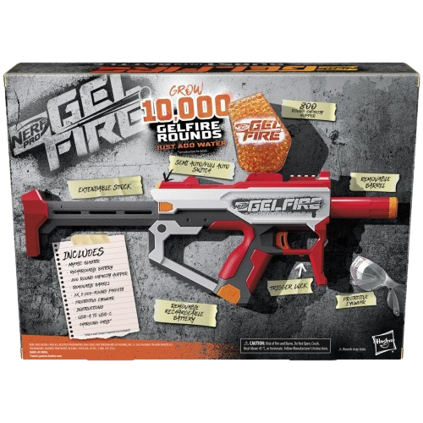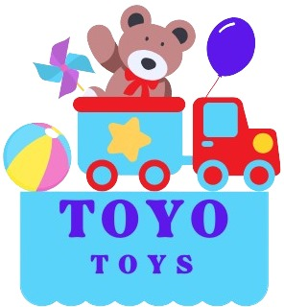

**Nerf Gel Fire**

**Price: $29.99**

**Experience the thrill of Gel Fire with NERF's authentic design.**

**Soft, non-toxic, and biodegradable for safe play.**

**Nerf Gel Fire is an innovative and exciting addition to the Nerf brand, offering a new way to engage in blaster battles. Instead of traditional foam darts, Nerf Gel Fire blasters shoot eco-friendly, water-based gel beads that explode on impact, providing a fun and unique experience.**

**.**

.

**Product details**

**THANK YOU!**

**WELLCOME TO OUR WEBSITE**